BUBBLE SORT

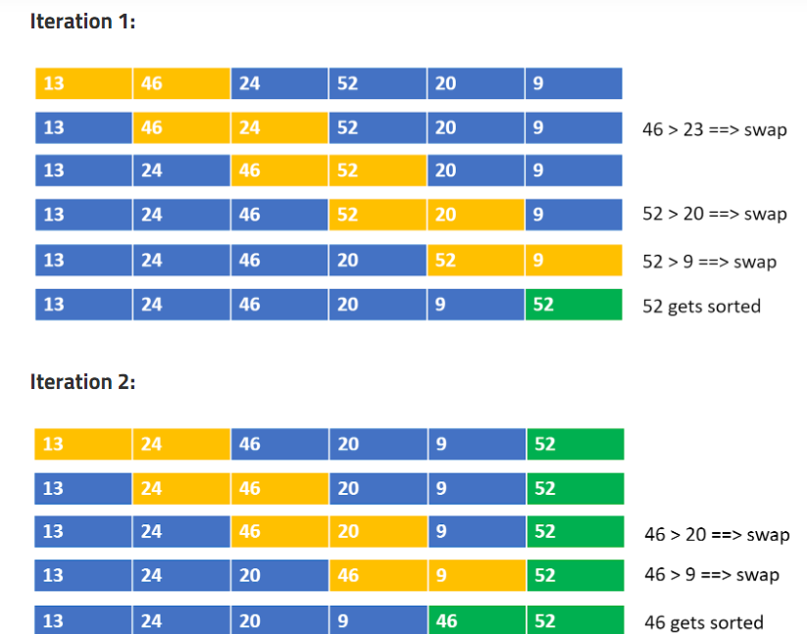

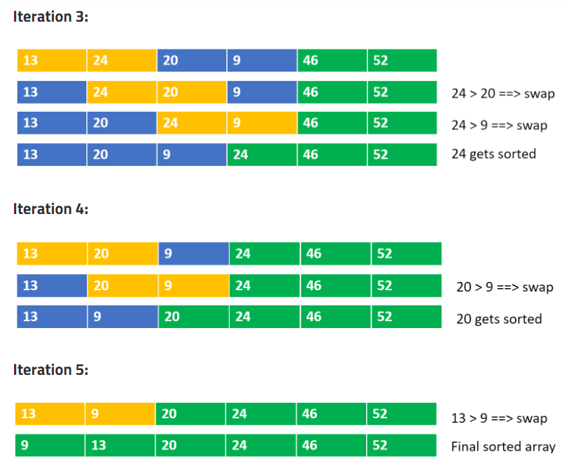

Brute:

def bubbleSort(arr: List[int], n: int):

    for i in reversed(range(1,n)):

        for j in range(0,i):

            if arr[j]>arr[j+1]:

                arr[j],arr[j+1]=arr[j+1],arr[j]

    return arr

Optimal;

def bubbleSort(arr: List[int], n: int):

    for i in reversed(range(1,n)):

        swap=0

        for j in range(0,i):

            if arr[j]>arr[j+1]:

                arr[j],arr[j+1]=arr[j+1],arr[j]

                swap=1

        if swap==0:

            break

    return arr

#If array is sorted there would not be any swaps

Recursive Bubble Sort:

def recur(arr,n,i):

    if i==0:

        return

    swap=0

    for j in range(0,i):

        if arr[j]>arr[j+1]:

            arr[j],arr[j+1]=arr[j+1],arr[j]

            swap=1

    if swap==0:

        return

    recur(arr,n,i-1)

def bubbleSort(arr: List[int], n: int):

    recur(arr,n,n-1)

    return arr